RAJALAKSHMI INSTITUTE OF TECHNOLOGY
DEPARTMENT OF INFORMATION TECHNOLOGY
IT-6512
WEB PROGRAMMING
WORKBOOK AND LAB MANUAL

Name of the Student :
Roll No :
Class :
Ex.No: 1
Date:
Topic: WEB SERVICES
AIM:
To implement the application using web service.
DESCRIPTION:
Create a new project in NetBeans.
Select screen as GlassFish
Create a webservice. In the design view→click add operation
Create a webservice code
Make modifications in source view
Click method and test the webservice and give input.
Procedure :
1.Create a new Project in NetBeans
Click→File→New Project
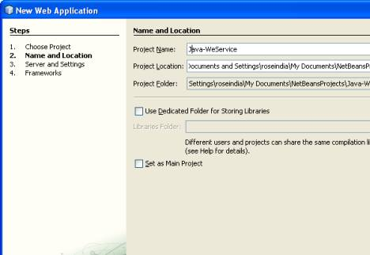

2.Select the Server as GlassFishV2
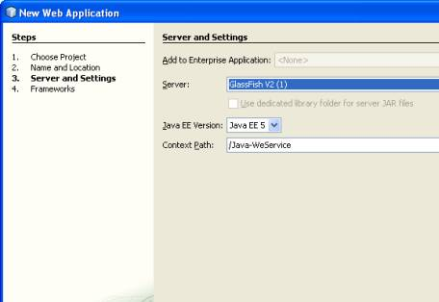
3.To develop WebService
Right Click the project Click on New→ WebService
It Will Create a Web Service .In the design view →Click on Add Operation.
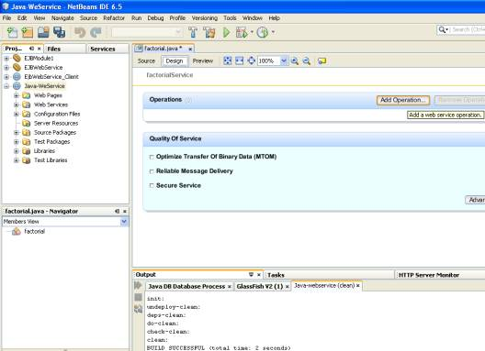

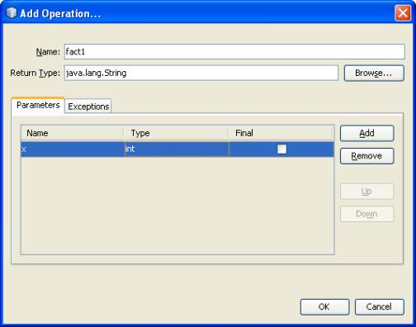

4.In the Fig above
give the name as fact1
Return type as String Give one parameter name x
Data type as int
Click on ok
This will create the Web Service code with the
name as factorial and method name as fact1
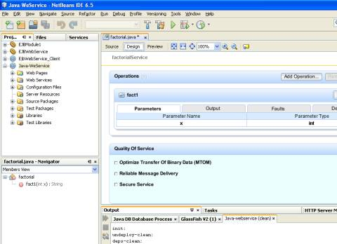
5. Now click on the source view
Here make some modification in the business logic for Method
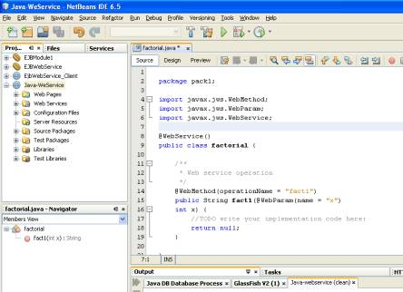

6. Right Click on the Factorial method and click on →Test WebService
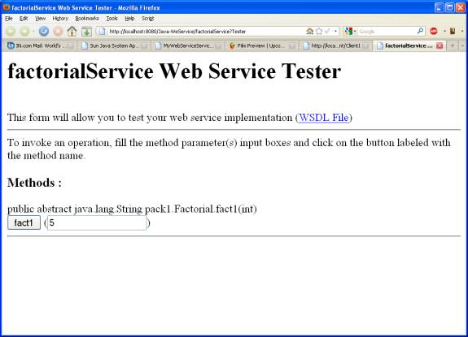
7.Give the Input for the factorial

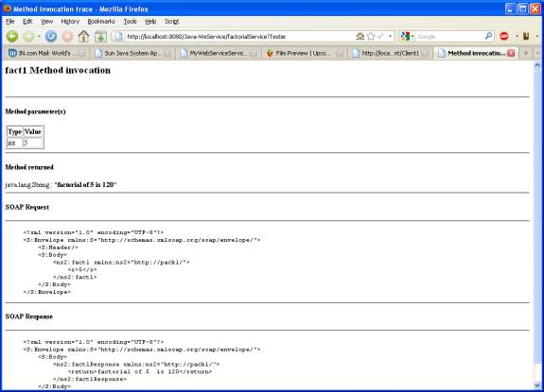

Program:

Output:
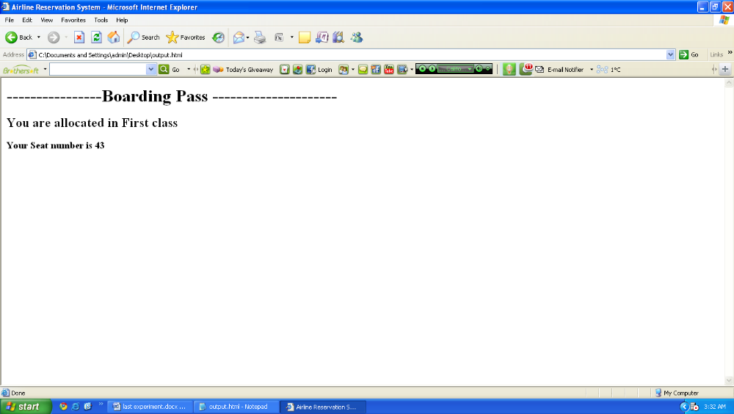

RESULT:
Thus an application using web service was executed successfully.

